**THE 3D MAPS :**

**Mesh Plot of Sensor Data :**

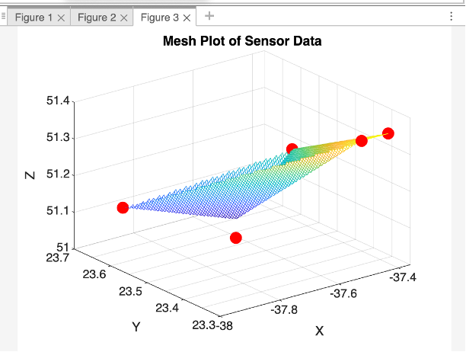

**3D Scatter Plot With Gas Concentration Color-Coding :**

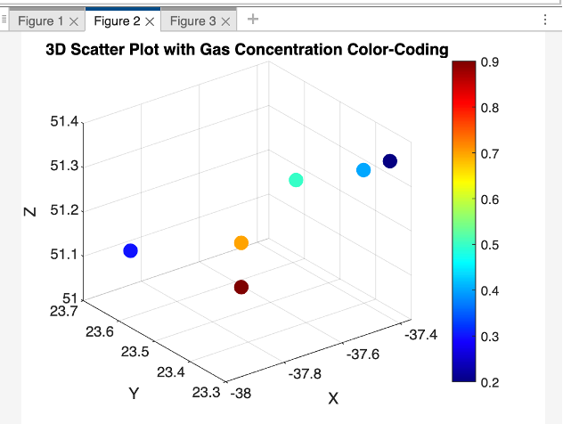

**OIL DETECTION PHOTOS:**

* **Region-Based Segmentation:**
* **No oil leak**

* **With oil leak**

* **K-Means Clustering:**
* **No oil leak :**

* **With oil leak**

* **Thermal Imaging:**
* **No oil leak :**

* **With oil leak :**

